As I work with databases more and more, it would be a great idea to document the methods that work for me and easy reproducible steps to cut back development time and help get the hang of it. There will also be some general tips.

SqlCommand -> Insert, update, delete (Sending commands)  
SqlDataReader -> Just reads and basically gets select queries

SqlAdapter -> Kind of like an E all of the above when I want it. The issue is that it’s a bit slower. Know what I need and use the right one.

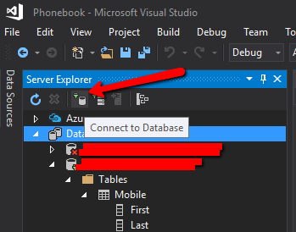

Once I have a project ready to connect to a DB.

Go to server explorer. click on the Connect to DB button

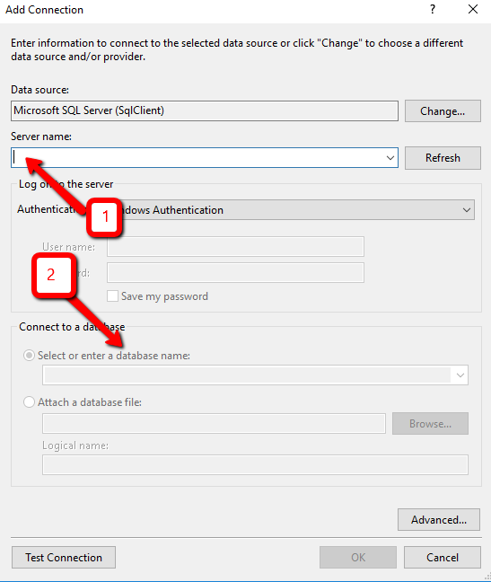

Then you can either put a . (Period) where server name is or your computers name. You can right click properties my computer and get it there if you don’t want to use a Period.

Where the 1 is, is where you put the Period.

Where the 2 is, you put the name of the database that you want to create.

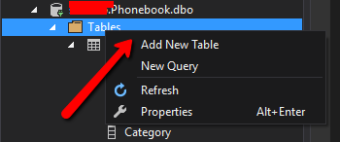

Right click on the Tables folder and go to Add New Table and there you go. So far so good.

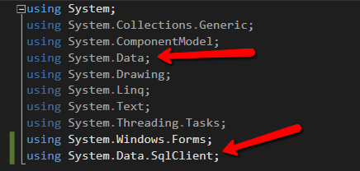

Make sure that you add the using namespaces

Using System.Data;

Using Syste.Data.SqlClient;



Next I go to the button that will need to use the SQL connection.

If its SqlAdapter, I would not need to open and close the connection but if I am using command/reader I do.   
That is simple though,

con.Open();

My SQL Statement

con.Close();